 

**Placement Empowerment Program**

***Cloud Computing and DevOps Centre***

TASK 1: Host a Static Website Locally: Set Up a Local Server Apache and Host a Simple HTML page with your name

Name: Bhuvana.K Department : CSE

**Introduction**

You'll learn how to host a simple static website locally on your computer using the Apache HTTP Server. Apache is one of the most widely used web servers for hosting websites, and by using it locally, you can test and develop your website before deploying it to the internet.

A static website consists of HTML, CSS, and possibly JavaScript files that do not change dynamically on the server. Instead, when a user requests a webpage, the server simply delivers the stored files. In this case, we'll be creating a simple HTML page that introduces yourself.

**Overview**

Install Apache**: First, you'll need to install the Apache server on your computer. This software will serve your static website files locally.**

* Create a Simple HTML File: You'll then create a basic HTML file that contains an introduction of yourself, which will be displayed on the website.
* Configure the Apache Server: You'll configure the Apache server to recognize and serve your HTML page.
* View Your Website Locally: Once Apache is running and your HTML page is in place, you can view your local website by navigating to the appropriate address in your web browser.

**Objective**

The goal of this project is to:

1. Set up a local web server using Apache.

2. Configure the server to host static files.

3. Create and host a simple HTML page displaying your name.

**Importance of Local Hosting**

Local hosting is an essential skill for developers, as it allows them to test and experiment with web applications in a controlled environment. It offers several advantages, such as:

**1.** Development and Testing

2. No Internet Required

3. Control and Flexibility

4. Learning and Experimentation

**Step-by-Step Procedure**

Step1:

Install "Apache Lounge" from the official website from google search.on

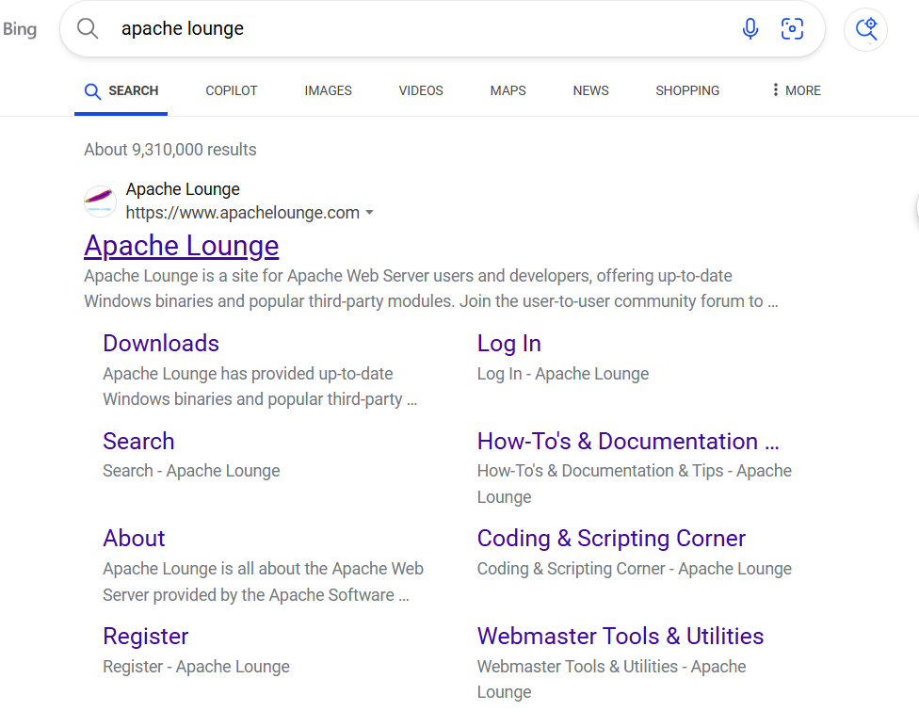

Step 2 :

Click on the "Downloads" option located on the left-hand side of the Apache Lounge website.

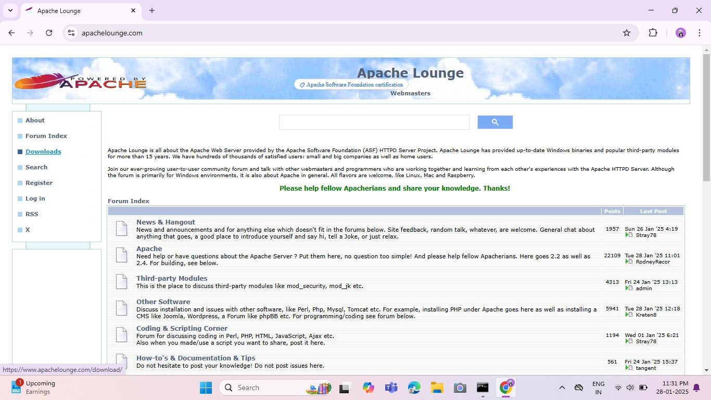

Step 3 :

Click on the link **"Apache 2.4.62-240904 Win64"** (Windows version), download the file.

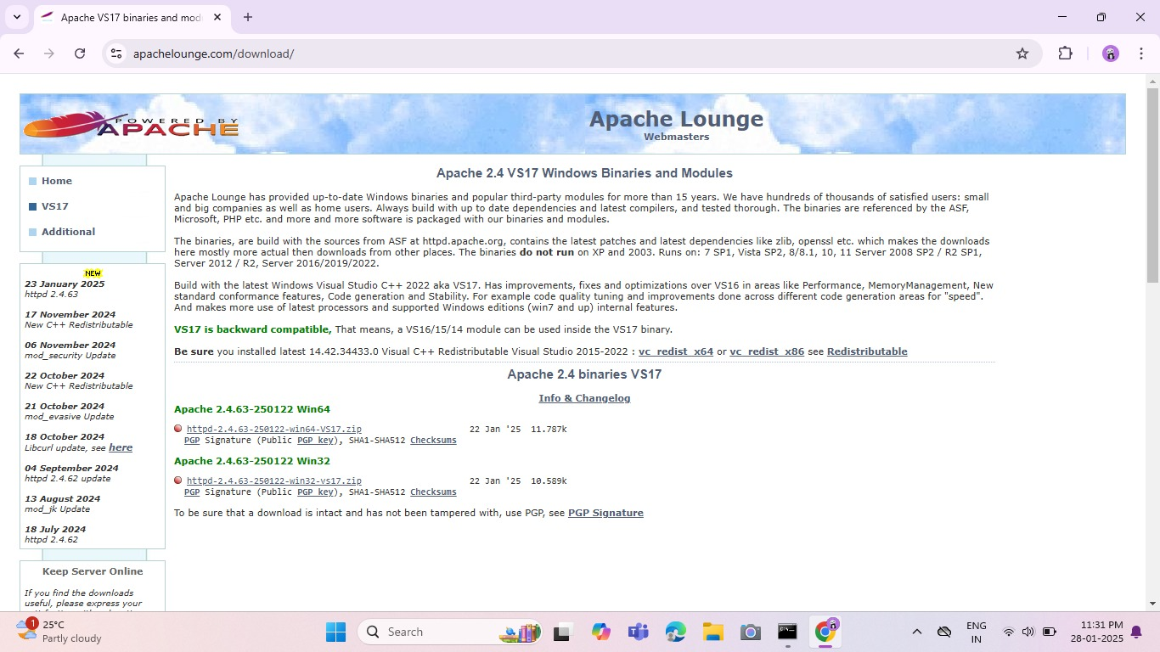

Step 4 :

Open Command Prompt as Administrator (Windows + R, type cmd, right-click and select 'Run as Administrator') and use the command cd C:\path\to\apache\bin to set the path to the Apache bin folder.

Screenshot 2025-01-22 155734.png

Step 5 :

Then Run the installation command :

**httpd.exe -k install**

Since I have already installed, it replies that “Service is already installed”.

Screenshot 2025-01-22 171122.png

Step 6 :

Go to the Apache folder you downloaded, go to the **conf** folder, and right-click on the **httpd.conf file;** select 'Edit with Notepad'

(Apache/conf/httpd.conf)

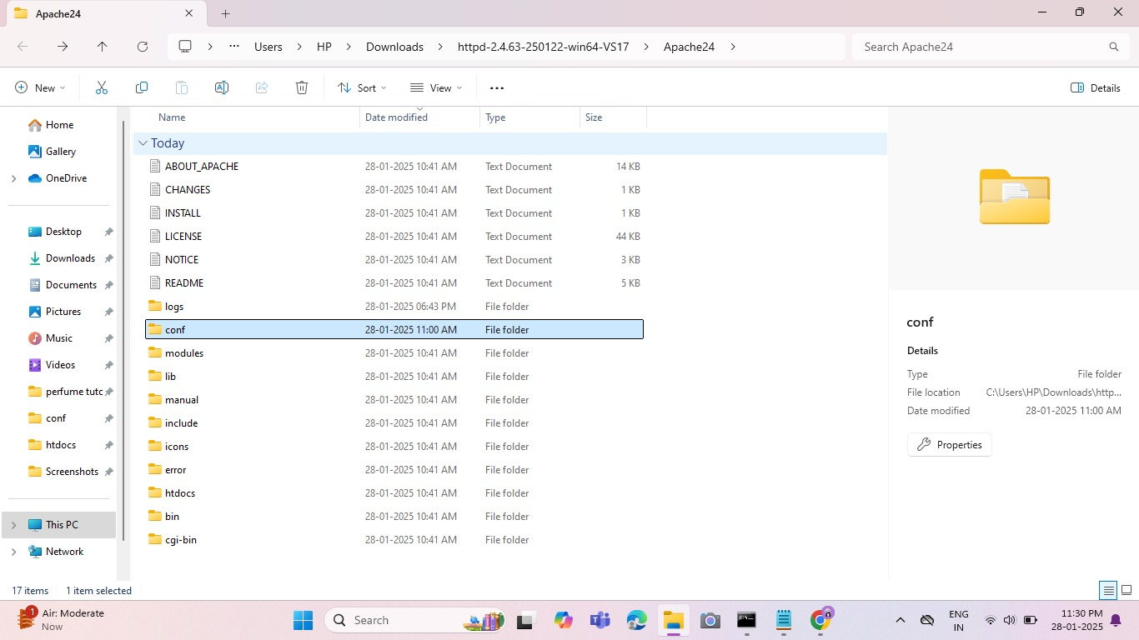

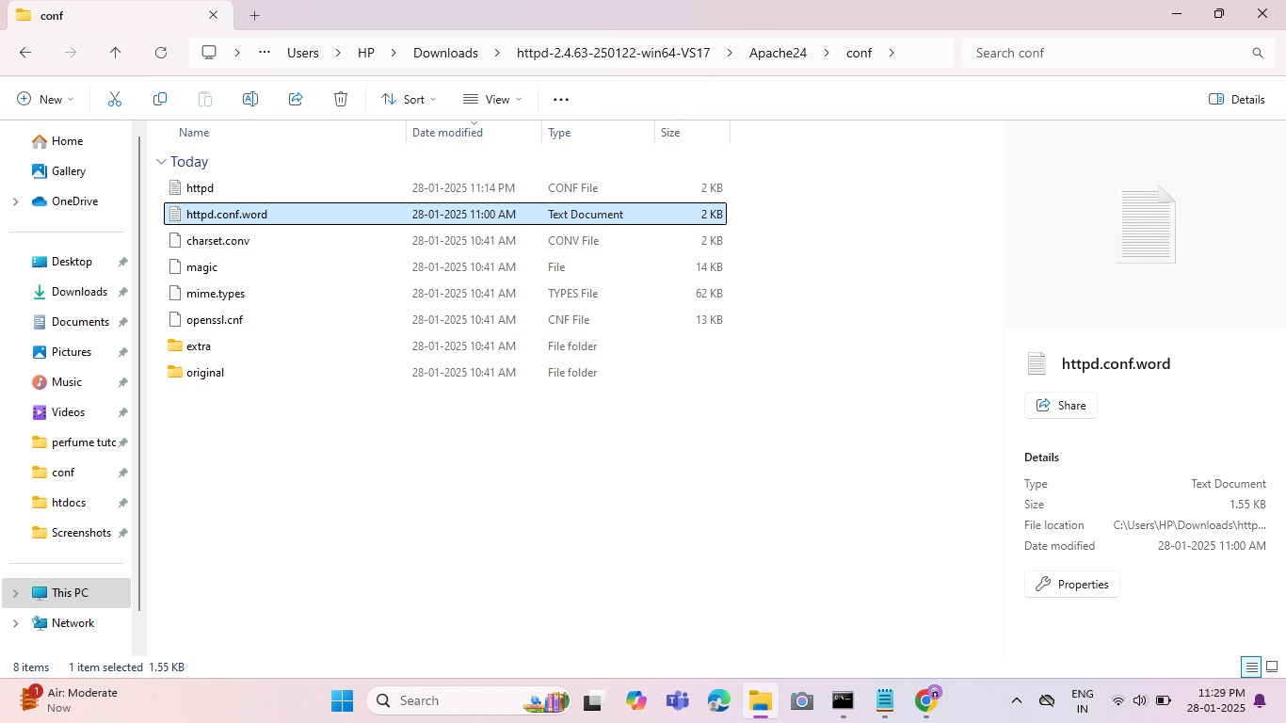

Step 7 :

Inside the **httpd.conf** file, replace the content with the provided configuration. Ensure you update the SRVROOT directive with your Apache installation path. This configuration defines the server’s root directory, listening port, modules, document root for serving web files, logging paths, and basic permissions, ensuring Apache serves content correctly from the specified htdocs directory.

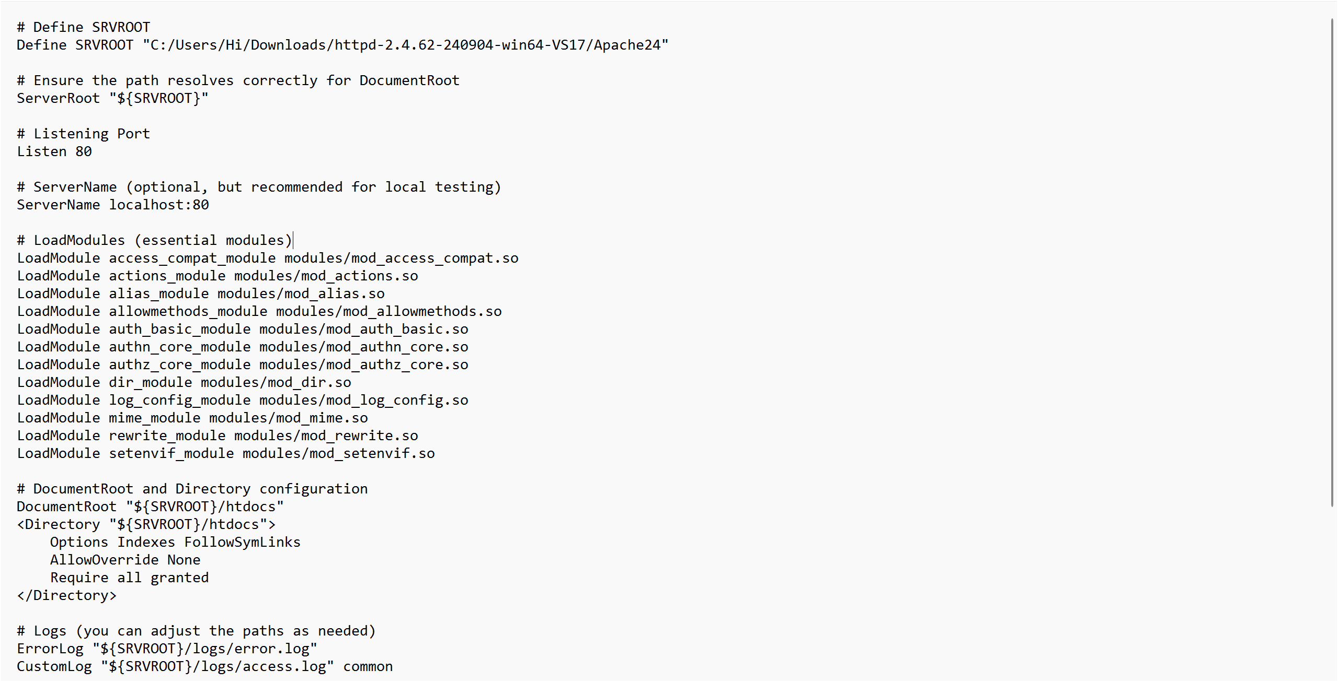

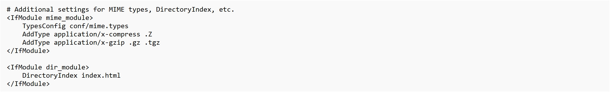

Step 8 :

Open Command Prompt and type the command **httpd.exe -t** to test the configuration file. If the configuration is correct, you should see **'Syntax OK**'.

Run the command **httpd.exe -k** start to start the Apache server.

Screenshot 2025-01-22 173330.png

Step 9:

Go to the Apache folder, navigate to the **htdocs** folder, and find the **index.html** file. Right-click on it and select 'Edit with Notepad'.

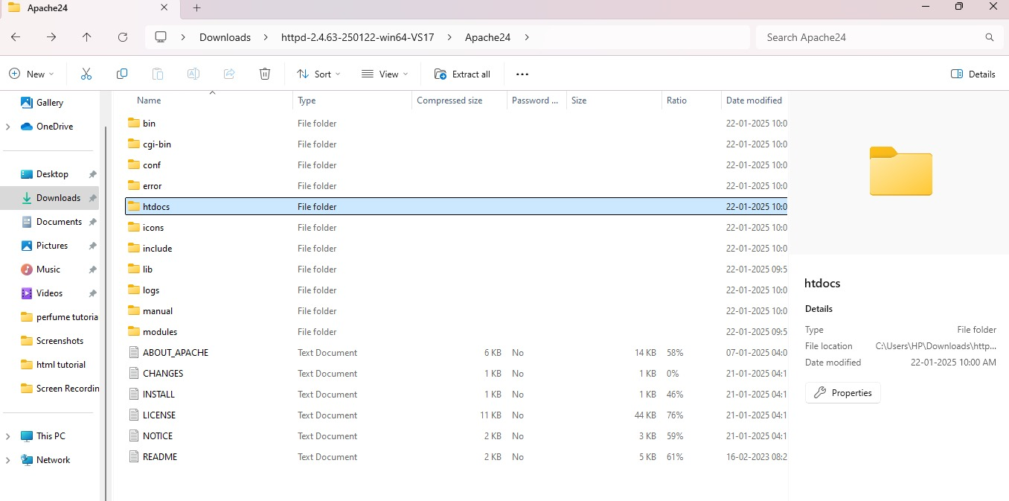

Step 10 :

Index.html file has been created.

Create a simple model to display your name in HTML

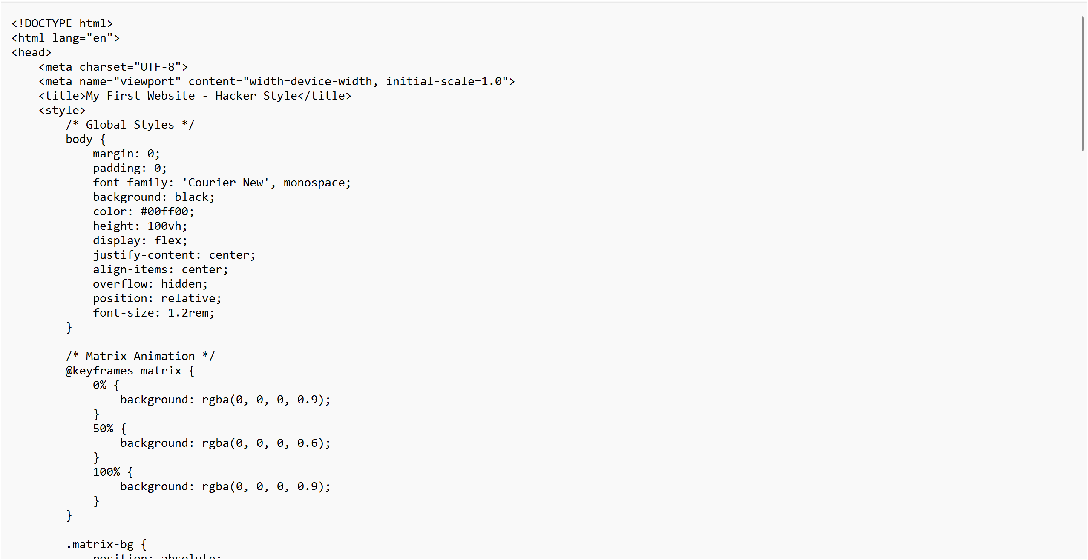

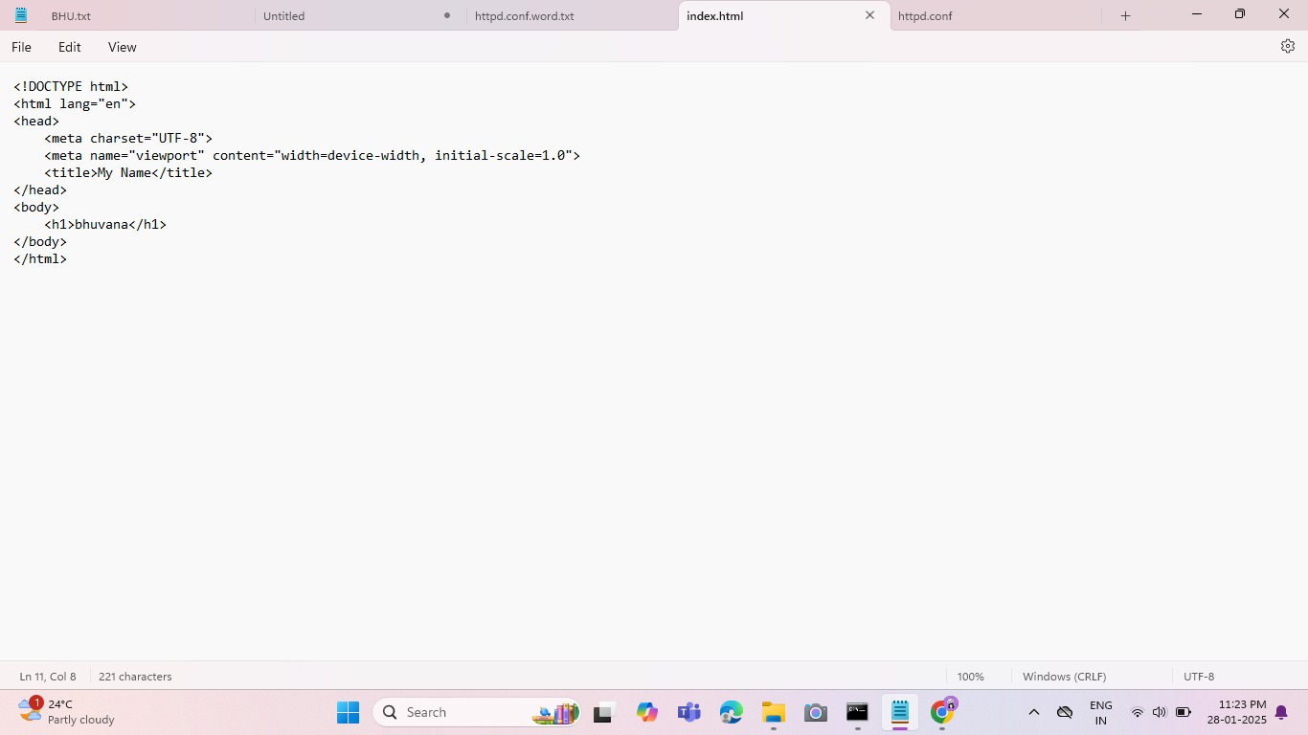

Step 11 :

Open the Chrome browser and type **index.html** in the address bar. You can able to see the website hosted successfully.

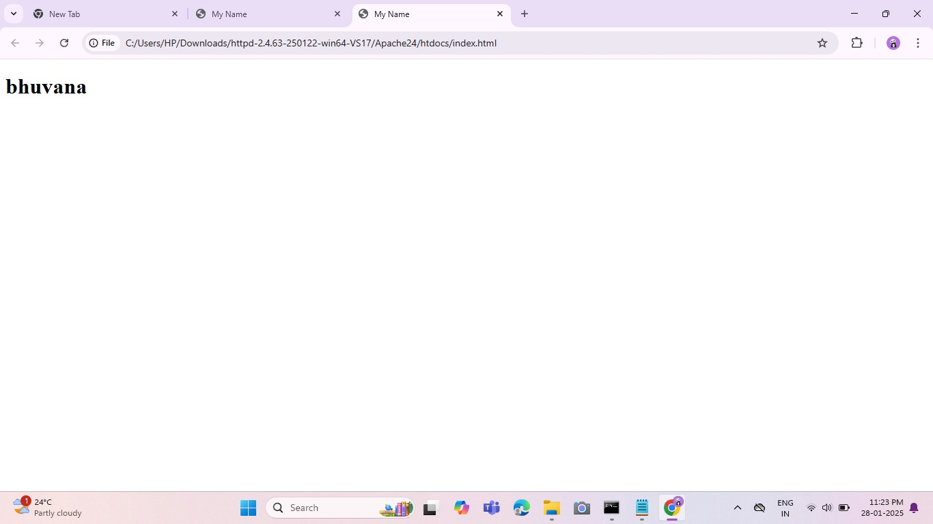

**Expected Outcome**

By completing this POC, you will:

1. Successfully configure and run an Apache server locally.

2. Host a static HTML website that displays your name.

3. Understand the basics of web server configuration and file hosting.